STA 6016 Assignment 1

Fuzzy Inference System (FIS)

Introduction
The study investigates the use of fuzzy logic to improve bicycle route selection by modelling qualitative variables, such as route length, elevation, and road roughness, in a human-understandable manner. Some of the main objectives of this study are:
- Enhancing bicycle routing selection beyond numerical cost metrics by applying a fuzzy inference system (FIS).
- Providing intuitive verbal descriptors like “short” or “uneven” and a ranked recommendation for multiple route options.
- Reducing cognitive load and support informed decision-making for cyclists.

Methodology
The study applies a Mamdani-type fuzzy inference system to translate quantitative route characteristics into qualitative, human-readable assessments of bikeability. Instead of evaluating routes purely through numerical costs, the FIS models use subjective reasoning through linguistic rules.

Linguistic Variables
In the fuzzification step, the normalized input values for each route are mapped to linguistic variables. Each linguistic variable represents a conceptual dimension of bikeability and is defined over the interval [0,1] after min–max normalization. The membership of a specific route value to a linguistic term is expressed as a degree between 0 and 1.
Input Variable Linguistic Values  Distance Short, Average, Long  Roughness Even, Normal, Uneven  Elevation Flat, Hilly | Output Variable Linguistic Values  Road Quality Low, Standard, High

Membership Functions
Membership functions were triangle-shaped for simplicity, as it was reported by the researchers. The triangles partly overlap, allowing a route to belong to multiple linguistic terms simultaneously to different degrees. For example, a route might be partially “even” and partially “uneven”, reflecting gradual transitions rather than hard thresholds.
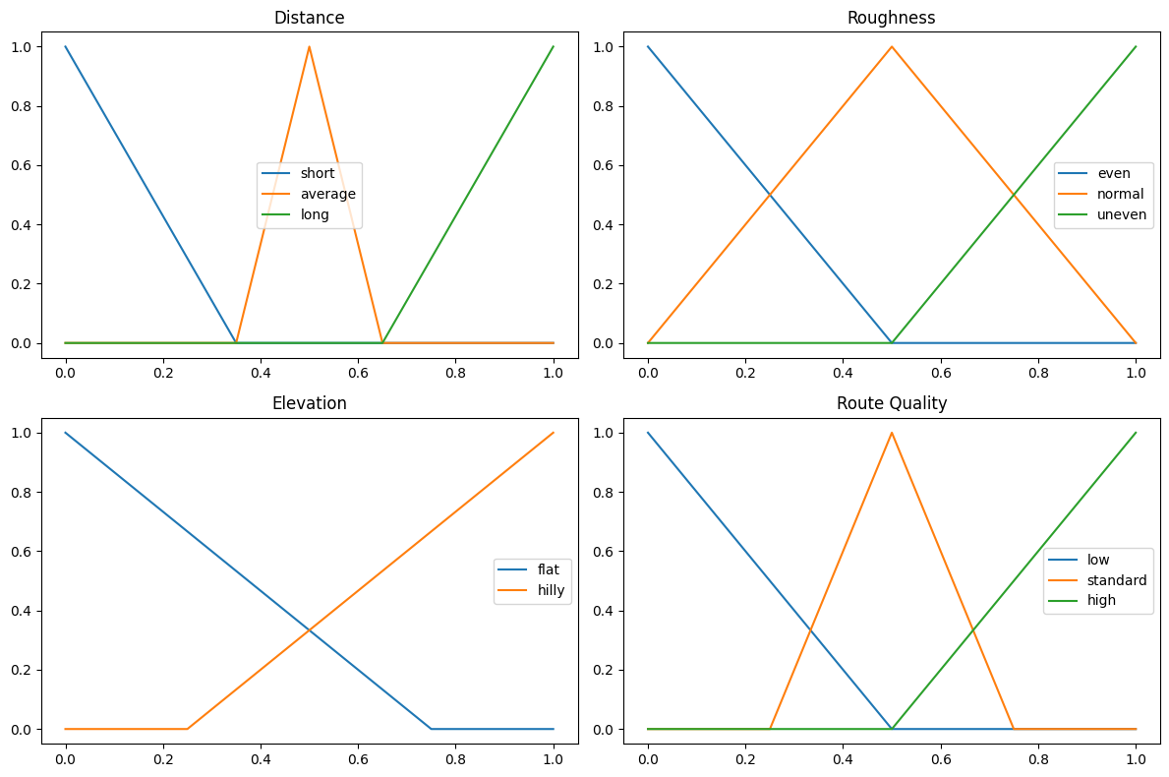
Figure 1: Membership functions of input and output variables

Fuzzy Inference Rules
The knowledge base consists of intuitive IF-THEN rules that connect input linguistic terms to output terms. For example, a rule states that,
“if a route is short, flat, and even, then its route quality is high”
During inference, the system evaluates these rules using fuzzy logic operators and aggregates the resulting output fuzzy sets.
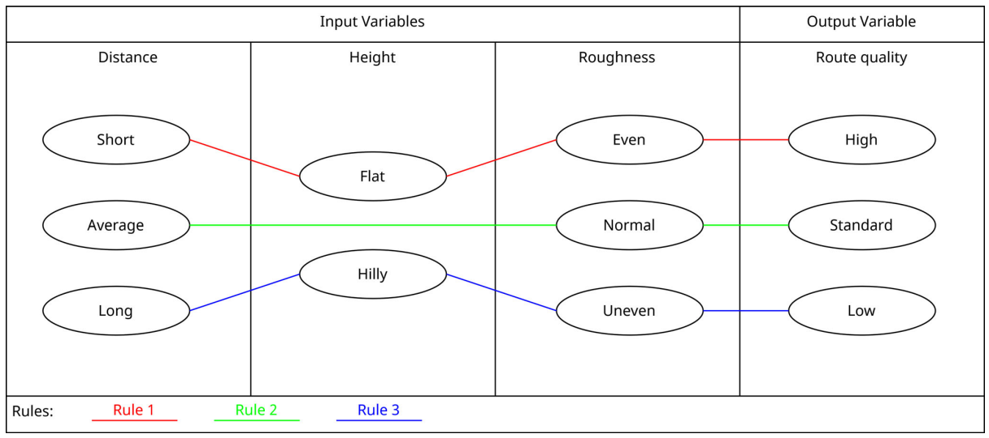
Figure 2: The rules of the FIS

Defuzzification
Finally, defuzzification is performed using the center-of-gravity method to obtain a single crisp route quality value between 0 and 1. This value enables direct ranking of the routes while preserving the qualitative reasoning structure embedded in the linguistic variables and membership functions.

Experimental Setup
The experimental setup is based on a case study in the Jakobervorstadt district of Augsburg, Germany. Three alternative bicycle routes between the same origin and destination were generated using OpenStreetMap data via OSMnx and the Dijkstra algorithm.
Each route was optimized with a different cost factor: one minimized total length, one minimized an elevation-based index, and one minimized a pavement roughness index combined with length. This ensures that the three routes reflected different aspects of bikeability.
Metrics / Fuzzy Set | Green Route | Blue Route | Orange Route
Length [m] | 1146 | 1393 | 1182
Short | 1.00 | – | 0.56
Average | – | – | –
Long | – | 1.00 | –
Elevation [unitless] | 37.42 | 33.72 | 42.48
Flat | 0.44 | 1.00 | –
Hilly | 0.23 | – | 1.00
Roughness [unitless] | 1205 | 1426 | 1053
Even | 0.34 | – | 1.00
Normal | 0.66 | – | –
Uneven | – | 1.00 | –
Route Quality | 0.67 | 0.17 | 0.81

Reconstructing the Model in Python
The model was reconstructed using the scikit-fuzzy library in Python. The minimum and maximum values of each variable were inferred from the values with membership values 1.
Then, using the “Green Route” values and min-max normalizing them produces the following results:
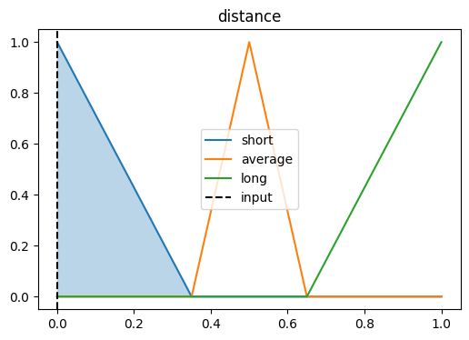 | 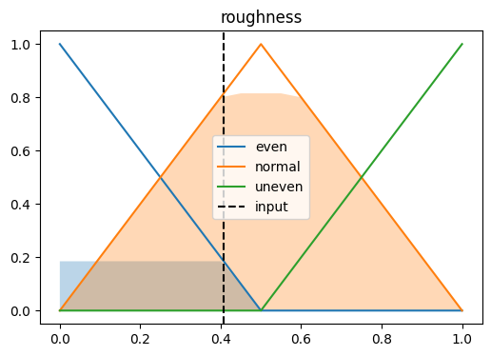 | 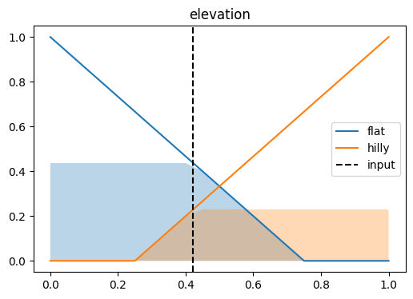
Distance: 0.0  - short: 1.0  - average: 0.0  - long: 0.0 | Roughness: 0.41  - even: 0.18  - normal: 0.82  - uneven: 0.0 | Elevation: 0.42  - flat: 0.44  - hilly: 0.23
The system calculates the output “Route Quality” as 0.77, which is close to the experimental result 0.67 reported in the study.

Conclusion
- Fuzzy logic provides qualitative reasoning for route choice, enhancing user comprehension.
- Customizable membership functions and rules allow the system to adapt to individual cyclist preferences.
- This approach offers an alternative cost-based routing models, aligning with subjective human perception of bikeability.

References
- Löw, P.S., Krisp, J.M. & Keler, A. Enhancing Bicycle Route Selection with Fuzzy Logic: A Case Study in Augsburg. KN J. Cartogr. Geogr. Inf. (2025). https://doi.org/10.1007/s42489-025-00202-3

